**Church Online Platform Event Configuration Instructions**

Every event streamed through Church Online Platform (ChOP) must have a **Service** created and configured. These service events tell ChOP the source of the live stream feed, when the service begins, ends, when chat begins and ends, etc.

Creating a Service

1. Go to <https://rmcalvary.online.church/admin>. This page is the ChOP Admin page.
2. Click on **Services** on left side bar menu.

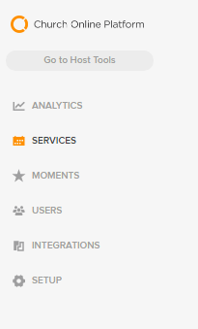

1. Click the **Add Services** button.

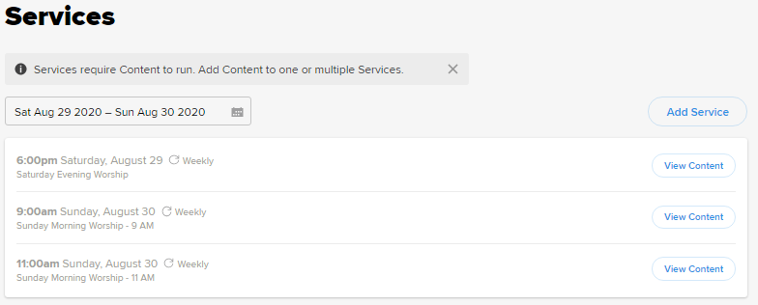

1. Configure the **Service** event information.

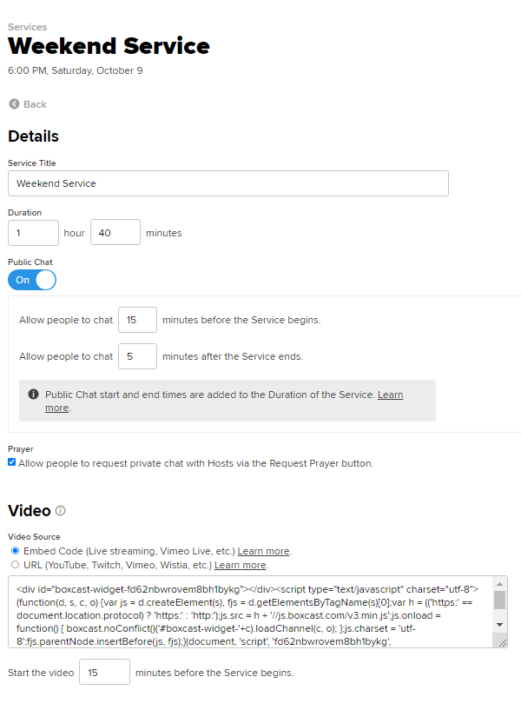

**The Embed Code is the live stream feed source. If this code is incorrect, the stream will not work. **Embed Code can be found at end of this document.**

**Give the service a title**

**Public chat should be turned on and set to begin 15 minutes before a service and end 5 minutes after service**

**This box should be checked to people can chat live with hosts for prayer**

**Set the event duration (a good value to begin with is 1 hour and 40 minutes. This value can be changed during a live service and extended if needed**

**The video should begin 15 minutes before service**

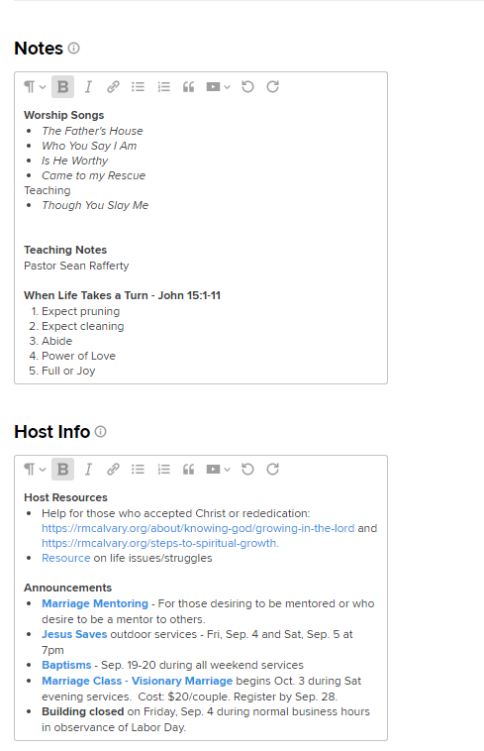

**Host Info is only visible to hosts. They are displayed when the when the Host Info tab is selected on the Hosts Tools view. Host resources and the announcements that will be shared at the weekly service should be entered in this field.**

**Notes are visible to guests and hosts. Notes are displayed on the “Notes” tab on the guest experience view under the chat window. They are also displayed on the Host Tools view under the “Notes” tab. Worship songs and teaching notes should be entered in this field.**

**Boxcast Embed Code**

Copy the code below and paste it into the service **Video** setting. Be sure to select the **Embed Code** video source option.

<div id="boxcast-widget-fd62nbwrovem8bh1bykg"></div><script type="text/javascript" charset="utf-8">(function(d, s, c, o) {var js = d.createElement(s), fjs = d.getElementsByTagName(s)[0];var h = (('https:' == document.location.protocol) ? 'https:' : 'http:');js.src = h + '//js.boxcast.com/v3.min.js';js.onload = function() { boxcast.noConflict()('#boxcast-widget-'+c).loadChannel(c, o); };js.charset = 'utf-8';fjs.parentNode.insertBefore(js, fjs);}(document, 'script', 'fd62nbwrovem8bh1bykg', {"showTitle":0,"showDescription":0,"showHighlights":0,"showRelated":false,"defaultVideo":"next","market":"house-of-worship","showDocuments":false,"showIndex":false,"showDonations":false}));</script>